8. Temperature Regulation in Vertebrates *Chapter 01, 46*

______________________________________________________________________________

I. Thermal Relations of Vertebrates *(1132-1136)*

A. Why Temperature is Important

1. Range of temperatures on earth

2. Temperature tolerances of living systems

3. Thermal sensitivity of biochemical reaction

B. Homeostasis and Temperature Regulation

1. Value of regulation

2. Concept of heat balance

C. Paths of Heat Exchange for All Animals

1. Radiation

2. Conduction

3. Convection

4. Evaporation

D. Thermoregulatory Strategies of Animals

1. Ectothermy

2. Endothermy

II. Endothermy *(1137-1140)*

A. Metabolic Rates and Heat Production

# B. Heat Conservation

1. Insulation

2. Piloerection

3. Whole animal behaviors

4. Circulatory system controls

C. Anatomical Correlates of Endothermy

D. Physiological Control of Temperature

1. Role of the hypothalamus

2. Precision of temperature control

III. Thermoregulation by Reptiles *(18-19, 1136-1137)*

A. Behavioral Thermoregulation

1. Exploitation of environmental opportunities

2. Behavioral mechanisms promoting heat exchange

B. Consequences of Thermoregulation

1. Body temperature variation

2. Relationship of body temperature to environmental temperatures

C. Evaluating Temperature Regulation

1. *Anolis cristatellus* and *A. gundlachi*

2. Geographical and ecological distributions

3. Using null hypotheses to demonstrate behavioral temperature regulation

8-1

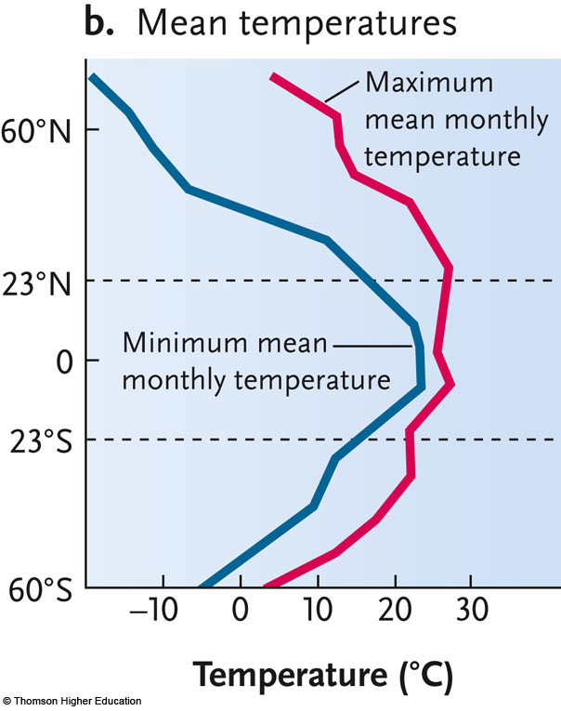

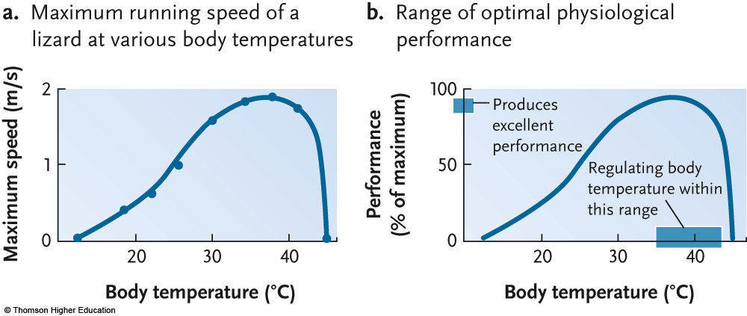

8-2

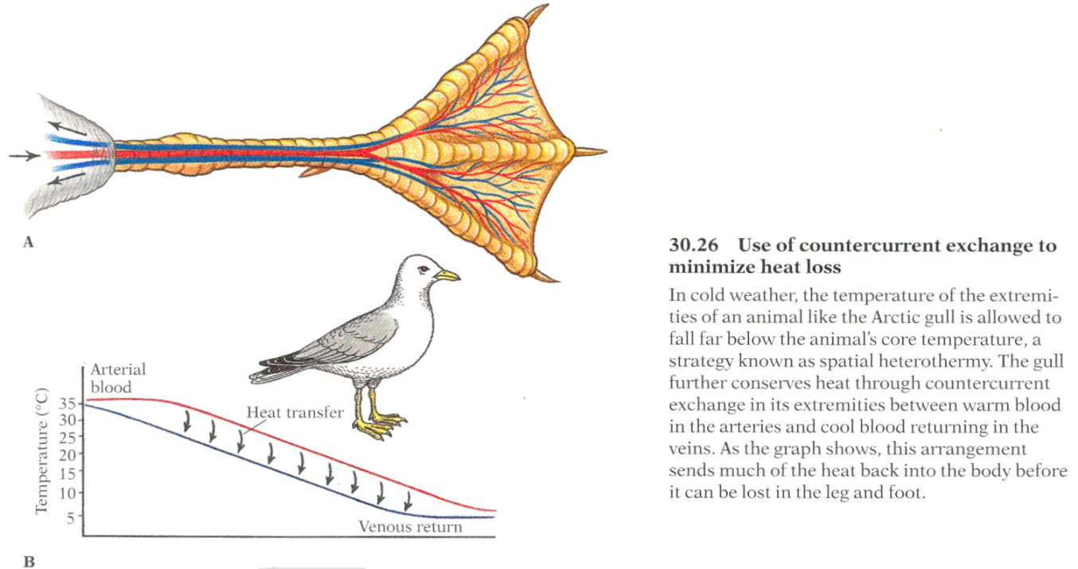

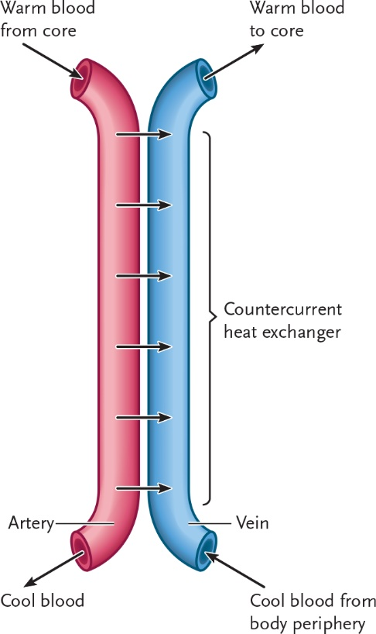

8-3

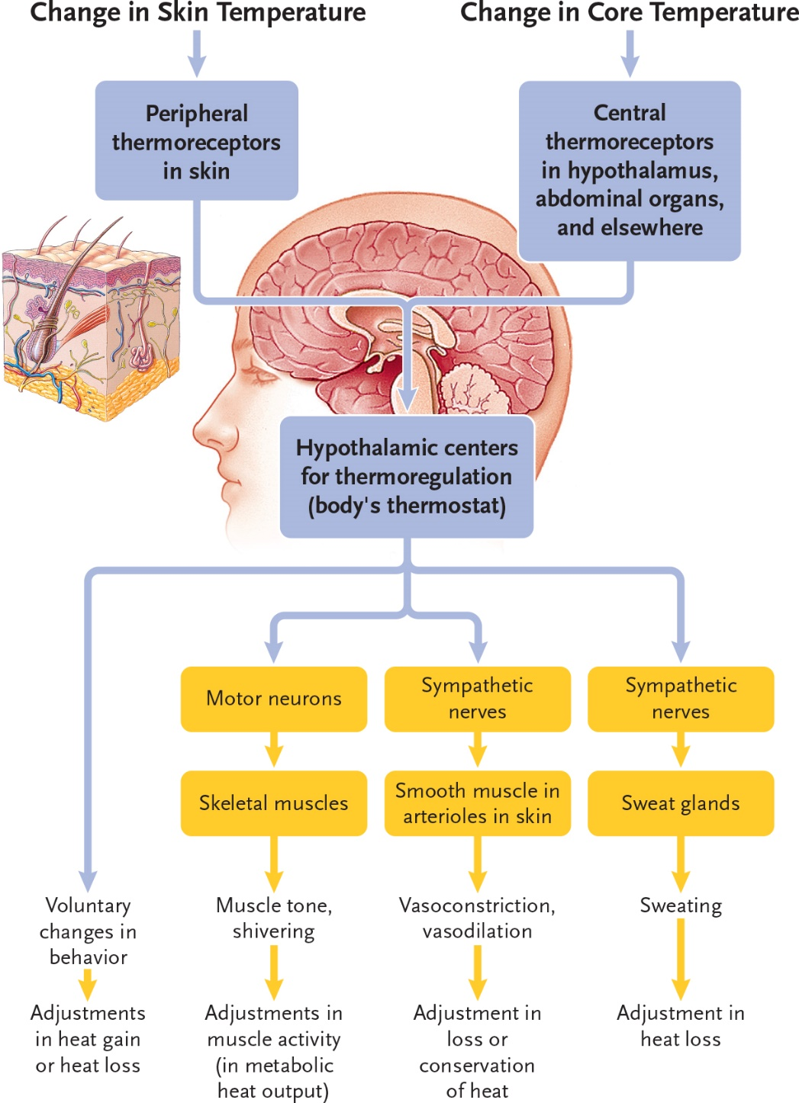

8-4

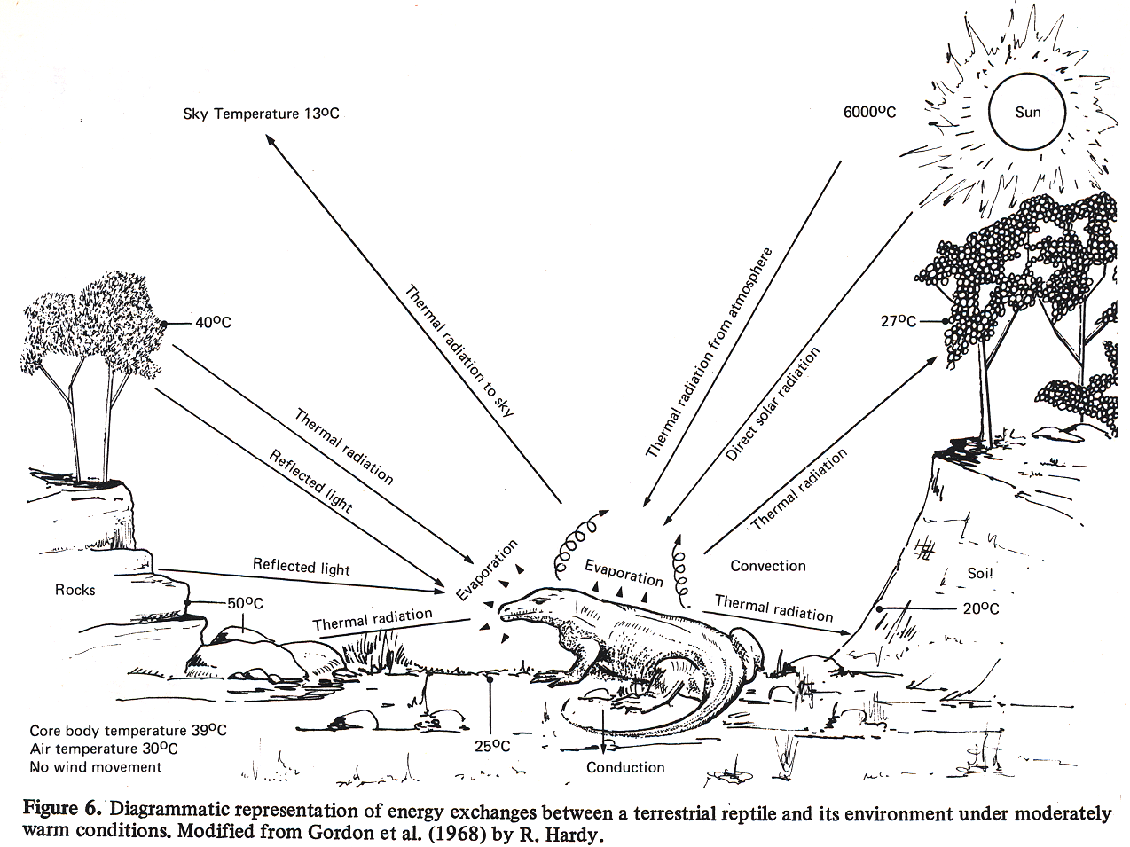

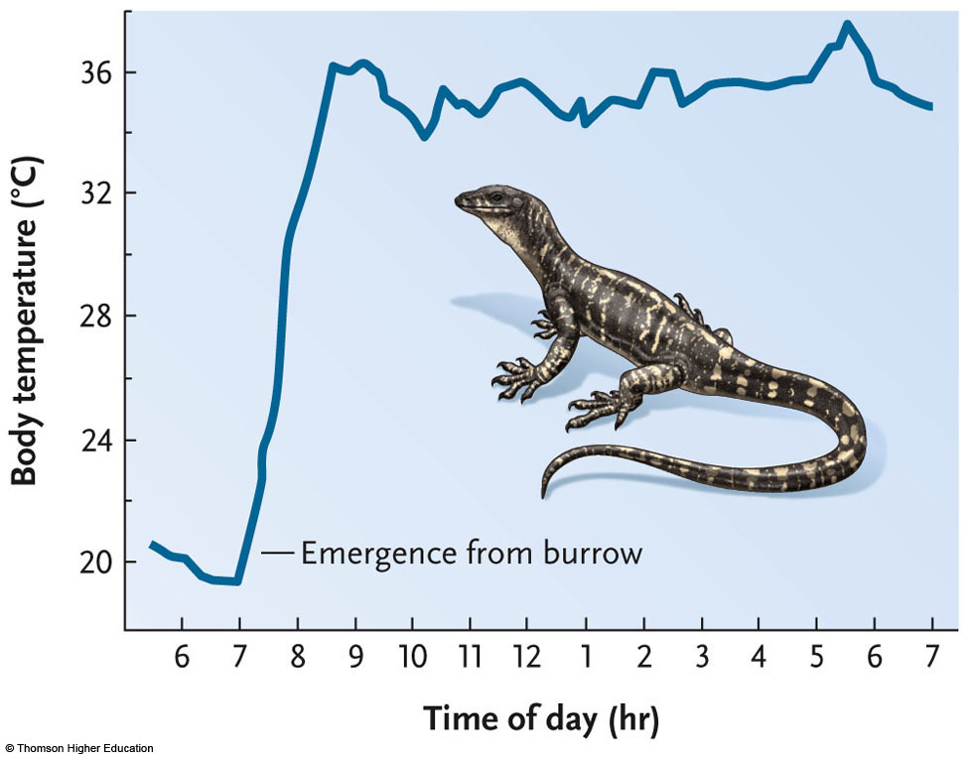

8-5

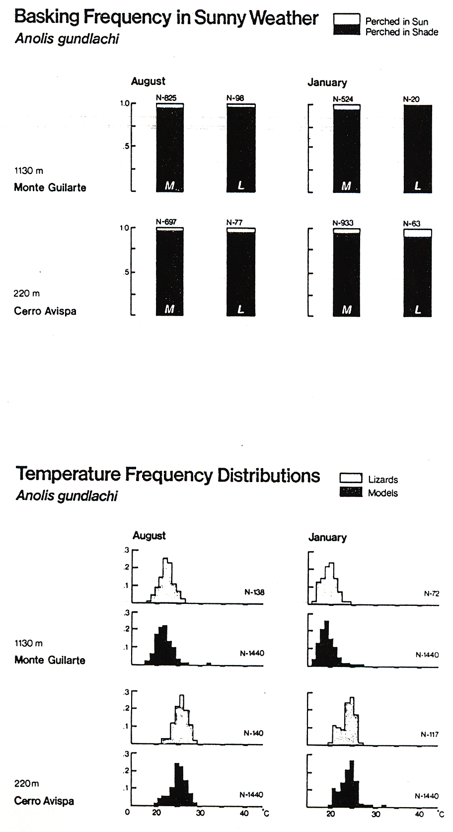

8-6

